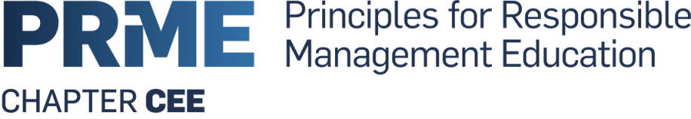

Regional meeting of the Central and Eastern European Chapter
30.-31. August 2017, room RB 205

Responsibility and Ethics in Management Education

30.8.2017:
9:00-9:30 Registration
9: 30 – 10:00 Welcome by the Chair Dušan Kučera and vice-rector: Prof. Dr. Jiri Hnilica
10: 00 – 10:45 2017 PRME Global Forum and 10th Anniversary discussion
and feedback , presented by Dr. Dušan Kučera, VŠE University, Prague.

10: 45 - 11:30 PRME CEE on how to further advance the Sustainable
Development Goals: what is done and further steps
(All participants, moderated by Julia Bulatova, RISEBA University).

11: 30 - 11:45 Coffee break
11: 45-13: 30 Ethical Responsibility in Management Education.
Holistic approach of.
(Keynote speaker: Prof. Dr. Mathias Schüz, ZHAW University)

13:30-14:30 Lunch
14:30-15:30 Responsible Management Education/ AACSB accreditation
(Irena Krzan, M.A., University of Ljubljana)

15:30-16:15 Examples of future oriented concept of city Prague
(Dr. Dušan Kučera, University of Economics, Prague)

16: 15 – 19: 00 City tour focusing on the history of the Charles University
(Klementinum, Karolinum, Strahov Monastry - libraries? )

19: 30 Dinner (members or steering committee).
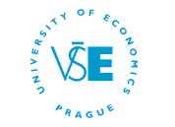

31.8.2017:
9: 00 -10: 30 Ethical Responsibility in Management Education.
Example of Automotive Industry II."
(Keynote speaker: Prof. Dr. Mathias Schüz, ZHAW University)

10: 30-10: 45 Coffee break
10: 45-12: 15 Ethics of Leadership and PRME principles for education
(Julia Bulatova, RISEBA University)

12: 15-13: 30 Lunch
--------------------------------------------------------------------------------------------------
13: 30 – 15: 00 Steering Committee meeting PRME CEE (only members of)

18: 00 Dinner in the city (for the members of steering committee).

